Quranic Verses and Translations.
Surah 1الفاتحہ
.4

4. Master of the Day of Judgment,
Surah 2 البقرہ
.132

132. The same did Abraham enjoin upon his sons, and also Jacob, (saying): O my sons! Lo! Allah hath chosen for you the (true) religion; therefore die not save as men who have surrendered (unto Him).
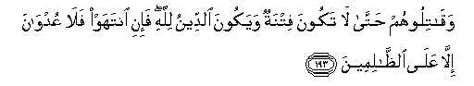 | .193
193. And fight them until persecution is no more, and religion is for Allah. But if they desist, then let there be no hostility except against wrong-doers.
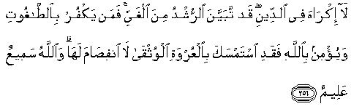 | .256

256. There is no compulsion in religion. The right direction is henceforth distinct from error. And he who rejecteth false deities and believeth in Allah hath grasped a firm handhold which will never break. Allah is Hearer, Knower.

Surah 3العمران
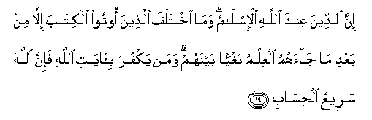 | .19

19. Lo! religion with Allah (is) the Surrender (to His Will and Guidance). Those who (formerly) received the Scripture differed only after knowledge came unto them, through transgression among themselves. Whoso disbelieveth the revelations of Allah (will find that) lo! Allah is swift at reckoning.
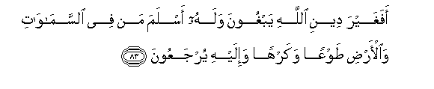 | .83

83. Seek they other than the religion of Allah, when unto Him submitteth whosoever is in the heavens and the earth, willingly or unwillingly, and unto Him they will be returned.

Surah 4النساء
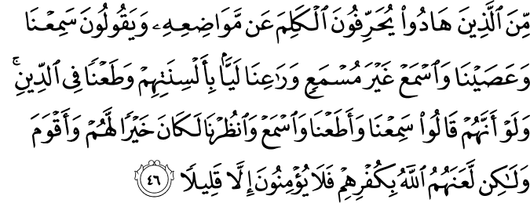

46. Some of those who are Jews change words from their context and say: "We hear and disobey; hear thou as one who heareth not" and "Listen to us!" distorting with their tongues and slandering religion. If they had said: "We hear and we obey: hear thou, and look at us" it had been better for them, and more upright. But Allah hath cursed them for their disbelief, so they believe not, save a few.
Surah 7الااعراف
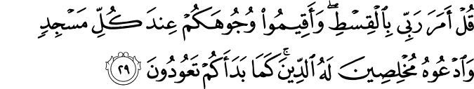

29. Say: My Lord enjoineth justice. And set your faces upright (toward Him) at every place of worship and call upon Him, making religion pure for Him (only). As He brought you into being, so return ye (unto Him).
Surah 8 الانفال
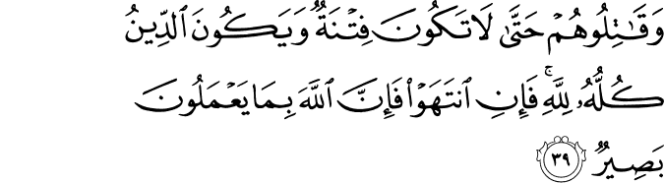

39. And fight them until persecution is no more, and religion is all for Allah. But if they cease, then lo! Allah is Seer of what they do.
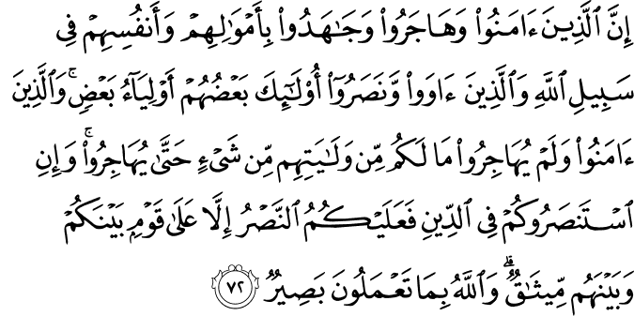

72. Lo! those who believed and left their homes and strove with their wealth and their lives for the cause of Allah, and those who took them in and helped them: these are protecting friends one of another. And those who believed but did not leave their homes, ye have no duty to protect them till they leave their homes; but if they seek help from you in the matter of religion then it is your duty to help (them) except against a folk between whom and you there is a treaty. Allah is Seer of what ye do.
Surah 9 التوبہ
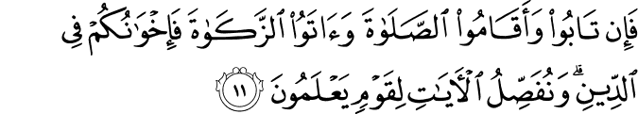

11. But if they repent and establish worship and pay the poor-due, then are they your brethren in religion. We detail Our revelations for a people who have knowledge.

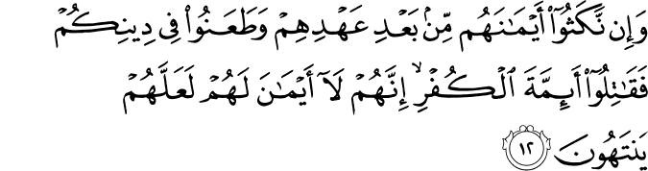

12. And if they break their pledges after their treaty (hath been made with you) and assail your religion, then fight the heads of disbelief - Lo! they have no binding oaths - in order that they may desist.
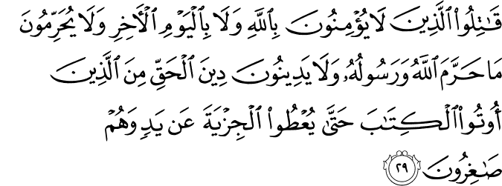

29. Fight against such of those who have been given the Scripture as believe not in Allah nor the Last Day, and forbid not that which Allah hath forbidden by His messenger, and follow not the Religion of Truth, until they pay the tribute readily, being brought low.
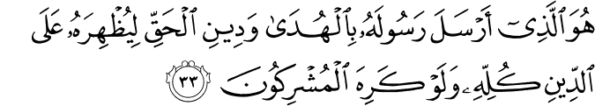

33. He it is Who hath sent His messenger with the guidance and the Religion of Truth, that He may cause it to prevail over all religion, however much the idolaters may be averse.
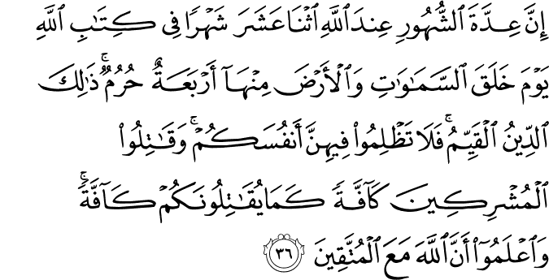

36. Lo! the number of the months with Allah is twelve months by Allah's ordinance in the day that He created the heavens and the earth. Four of them are sacred: that is the right religion. So wrong not yourselves in them. And wage war on all of the idolaters as they are waging war on all of you. And know that Allah is with those who keep their duty (unto Him).

Surah 10 یونس
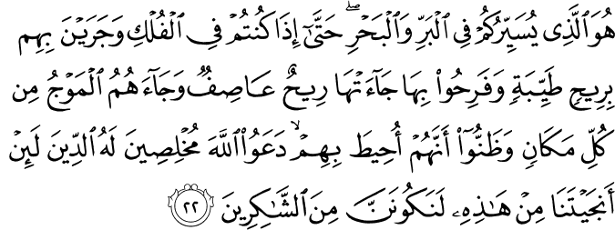

22. He it is Who maketh you to go on the land and the sea till, when ye are in the ships and they sail with them with a fair breeze and they are glad therein, a storm- wind reacheth them and the wave cometh unto them from every side and they deem that they are overwhelmed therein; (then) they cry unto Allah, making their faith pure for Him only: If Thou deliver us from this, we truly will be of the thankful.

105. And, (O Muhammad) set thy purpose resolutely for religion, as a man by nature upright, and be not of those who ascribe partners (to Allah).

Surah 12
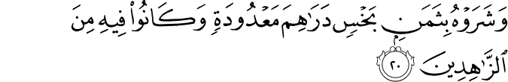
40. Those whom ye worship beside Him are but names which ye have named, ye and your fathers. Allah hath revealed no sanction for them. The decision rests with Allah only, Who hath commanded you that ye worship none save Him. This is the right religion, but most men know not.
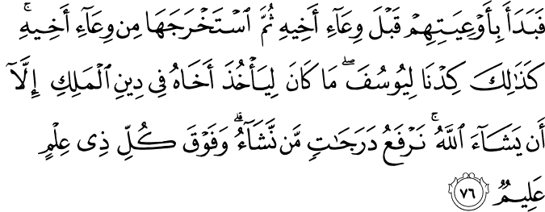

76. Then he (Joseph) began the search with their bags before his brother's bag, then he produced it from his brother's bag. Thus did We contrive for Joseph. He could not have taken his brother according to the king's law unless Allah willed. We raise by grades (of mercy) whom We will, and over every lord of knowledge there is one more knowing.
Surah 15 الحجر

35. And lo! the curse shall be upon thee till the Day of Judgment.
Surah 16 النحل
52. Unto Him belongeth whatsoever is in the heavens and the earth, and religion is His for ever. Will ye then fear any other than Allah ?
Surah 22 الحج
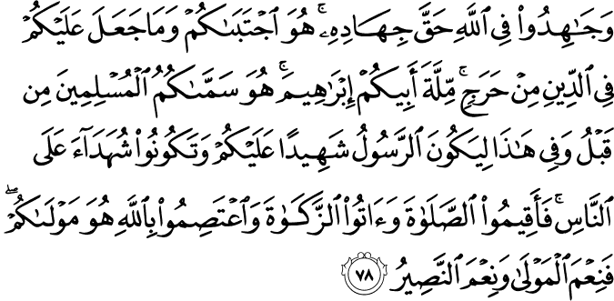

78. And strive for Allah with the endeavour which is His right. He hath chosen you and hath not laid upon you in religion any hardship; the faith of your father Abraham (is yours). He hath named you Muslims of old time and in this (Scripture), that the messenger may be a witness against you, and that ye may be witnesses against mankind. So establish worship, pay the poor-due, and hold fast to Allah. He is your Protecting friend. A blessed Patron and a blessed Helper!

Surah 24النور
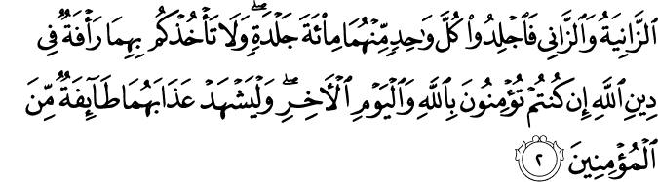

2. The adulterer and the adulteress, scourge ye each one of them (with) a hundred stripes. And let not pity for the twain withhold you from obedience to Allah, if ye believe in Allah and the Last Day. And let a party of believers witness their punishment.
Surah 29 سورۃ العنکبوت
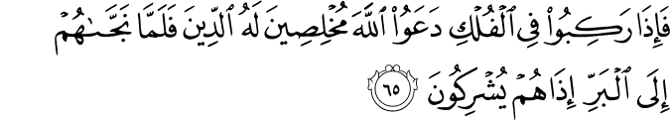

65. And when they mount upon the ships they pray to Allah, making their faith pure for Him only, but when He bringeth them safe to land, behold! they ascribe partners (unto Him),
Surah 30 الروم
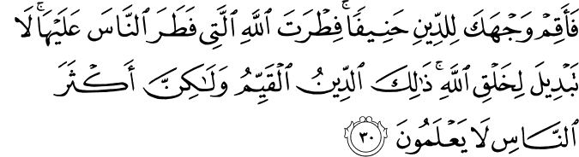

30. So set thy purpose (O Muhammad) for religion as a man by nature upright - the nature (framed) of Allah, in which He hath created man. There is no altering (the laws of) Allah's creation. That is the right religion, but most men know not –
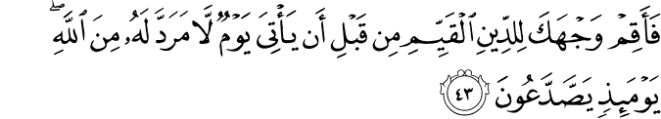

43. So set thy purpose resolutely for the right religion, before the inevitable day cometh from Allah. On that day mankind will be sundered-

Surah 31 لقمان
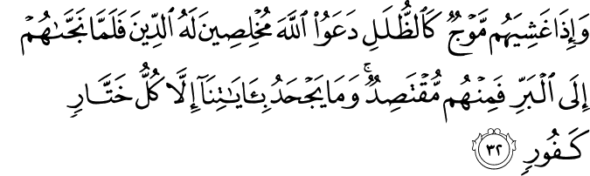

32. And if a wave enshroudeth them like awnings, they cry unto Allah, making their faith pure for Him only. But when He bringeth them safe to land, some of them compromise. None denieth Our signs save every traitor ingrate.
Surah 33 الااحزاب
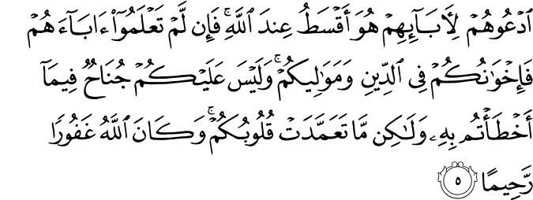

5. Proclaim their real parentage. That will be more equitable in the sight of Allah. And if ye know not their fathers, then (they are) your brethren in the faith, and your clients. And there is no sin for you in the mistakes that ye make unintentionally, but what your hearts purpose (that will be a sin for you). Allah is ever Forgiving, Merciful.
Surah 37 الصفات

20. And say: Ah, woe for us! This is the Day of Judgment.
Surah 38 ص
78. And lo! My curse is on thee till the Day of Judgment.
Surah 39 الزمر
2. Lo! We have revealed the Scripture unto thee (Muhammad) with truth; so worship Allah, making religion pure for Him (only).
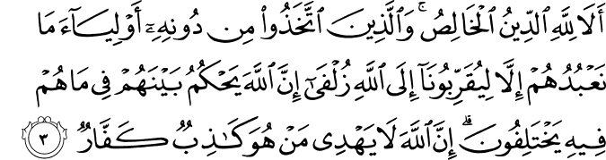
3. Surely pure religion is for Allah only. And those who choose protecting friends beside Him (say): We worship them only that they may bring us near unto Allah. Lo! Allah will judge between them concerning that wherein they differ. Lo! Allah guideth not him who is a liar, an ingrate.
11. Say (O Muhammad): Lo! I am commanded to worship Allah, making religion pure for Him (only).
Surah 40 سورٰۃ غا فر
14. Therefor (O believers) pray unto Allah, making religion pure for Him (only), however much the disbelievers be averse –
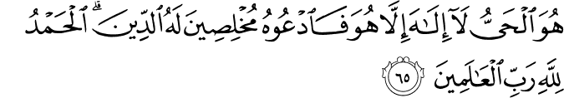
65. He is the Living One. There is no God save Him. So pray unto Him, making religion pure for Him (only). Praise be to Allah, the Lord of the Worlds!
Surah42سورۃ الشورٰہ
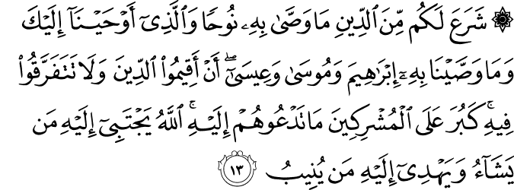

13. He hath ordained for you that religion which He commended unto Noah, and that which We inspire in thee (Muhammad), and that which We commended unto Abraham and Moses and Jesus, saying: Establish the religion, and be not divided therein. Dreadful for the idolaters is that unto which thou callest them. Allah chooseth for Himself whom He will, and guideth unto Himself him who turneth (toward Him).
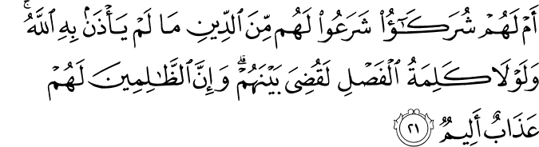
21. Or have they partners (of Allah) who have made lawful for them in religion that which Allah allowed not ? And but for a decisive word (gone forth already), it would have been judged between them. Lo! for wrong-doers is a painful doom.
Surah 48 الاحقاف
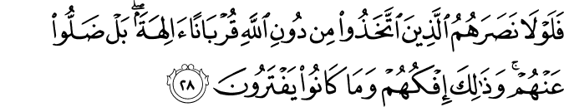

28. He it is Who hath sent His messenger with the guidance and the religion of truth, that He may cause it to prevail over all religion. And Allah sufficeth as a Witness.

Surah 51 الذاریات
6. And lo! the judgment will indeed befall.
12. They ask: When is the Day of Judgment ?

Surah 56 الواقعہ
56. This will be their welcome on the Day of Judgment.
Surah 60 الممتحنہ
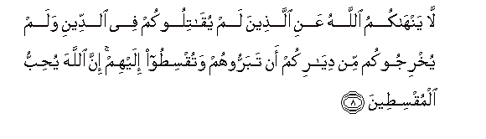 | .8
8. Allah forbiddeth you not those who warred not against you on account of religion and drove you not out from your homes, that ye should show them kindness and deal justly with them. Lo! Allah loveth the just dealers.

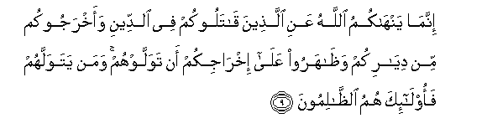 | .9

9. Allah forbiddeth you only those who warred against you on account of religion and have driven you out from your homes and helped to drive you out, that ye make friends of them. Whosoever maketh friends of them - (All) such are wrong- doers.
Surah 61 الصف
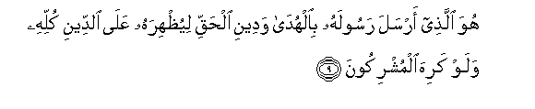 | .9

9. He it is Who hath sent His messenger with the guidance and the religion of truth, that He may make it conqueror of all religion however much idolaters may be averse.
Surah 70 المعارج
.26

Surah 74 المزمل
26. And those who believe in the Day of Judgment,
.46

46. And we used to deny the Day of Judgment,
Surah 82 الانفطار

9. Nay, but ye deny the Judgment.
.15

15. They will burn therein on the Day of Judgment,
.17

17. Ah, what will convey unto thee what the Day of Judgment is!
.18

18. Again, what will convey unto thee what the Day of Judgment is!
Surah 95 التین
.Then do We abase him (to be) the lowest of the low,- 5.
Surah 98 البینہ

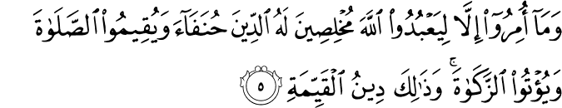
5. And they have been commanded no more than this: To worship Allah, offering Him sincere devotion, being true (in faith); to establish regular prayer; and to practise regular charity; and that is the Religion Right and Straight.
Surah 109 الکافرون
6. To you be your Way, and to me mine.
Surah 110 النصر
2. And thou dost see the people enter Allah's Religion in crowds,
دیناً
Surah 03 العمران

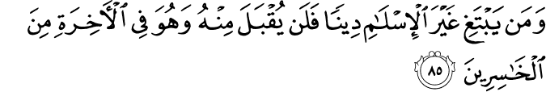
85. If anyone desires a religion other than Islam (submission to Allah), never will it be accepted of him; and in the Hereafter He will be in the ranks of those who have lost (All spiritual good). 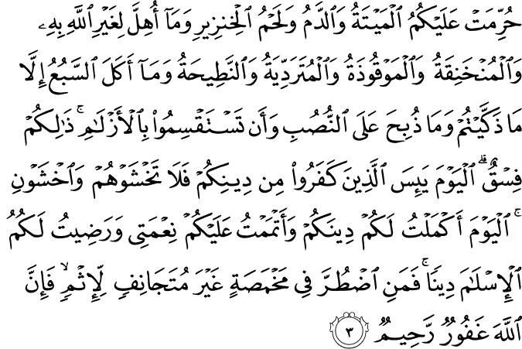
3. Forbidden to you (for food) are: dead meat, blood, the flesh of swine, and that on which hath been invoked the name of other than Allah; that which hath been killed by strangling, or by a violent blow, or by a headlong fall, or by being gored to death; that which hath been (partly) eaten by a wild animal; unless ye are able to slaughter it (in due form); that which is sacrificed on stone (altars); (forbidden) also is the division (of meat) by raffling with arrows: that is impiety. This day have those who reject faith given up all hope of your religion: yet fear them not but fear Me. This day have I perfected your religion for you, completed My favour upon you, and have chosen for you Islam as your religion. But if any is forced by hunger, with no inclination to transgression, Allah is indeed Oft-forgiving, Most Merciful.
دینکم
البقرۃSurah 2
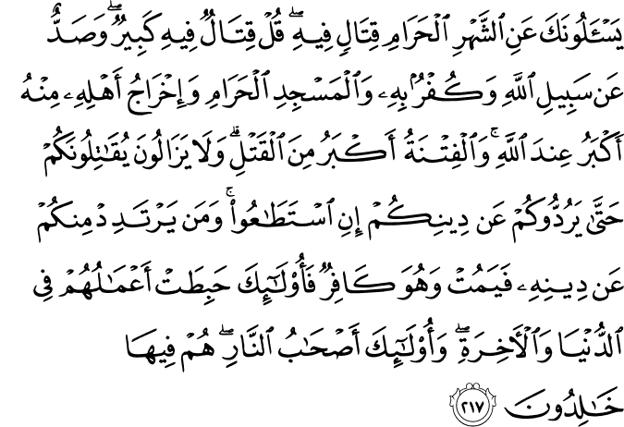

217. They ask thee concerning fighting in the Prohibited Month. Say: "Fighting therein is a grave (offence); but graver is it in the sight of Allah to prevent access to the path of Allah, to deny Him, to prevent access to the Sacred Mosque, and drive out its members." Tumult and oppression are worse than slaughter. Nor will they cease fighting you until they turn you back from your faith if they can. And if any of you Turn back from their faith and die in unbelief, their works will bear no fruit in this life and in the Hereafter; they will be companions of the Fire and will abide therein.
Surah 3 العمران
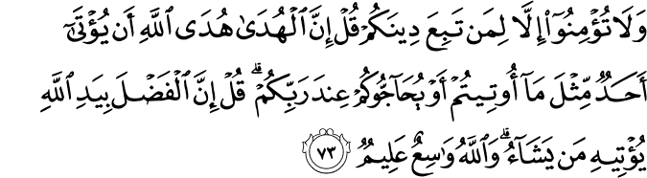

73. "And believe no one unless he follows your religion." Say: "True guidance is the Guidance of Allah: (Fear ye) Lest a revelation be sent to someone (else) Like unto that which was sent unto you? or that those (Receiving such revelation) should engage you in argument before your Lord?" Say: "All bounties are in the hand of Allah: He granteth them to whom He pleaseth: And Allah careth for all, and He knoweth all things."
Surah 4 النساء

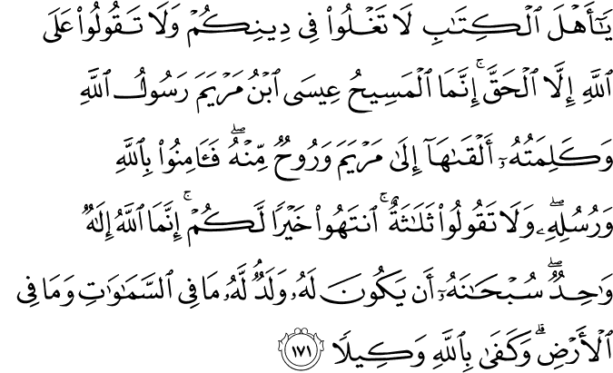
171.O People of the Book! Commit no excesses in your religion: Nor say of Allah aught but the truth. Christ Jesus the son of Mary was (no more than) a messenger of Allah, and His Word, which He bestowed on Mary, and a spirit proceeding from Him: so believe in Allah and His messengers. Say not "Trinity" : desist: it will be better for you: for Allah is one Allah: Glory be to Him: (far exalted is He) above having a son. To Him belong all things in the heavens and on earth. And enough is Allah as a Disposer of affairs.
Surah 5 المائدۃ

3.Forbidden to you (for food) are: dead meat, blood, the flesh of swine, and that on which hath been invoked the name of other than Allah; that which hath been killed by strangling, or by a violent blow, or by a headlong fall, or by being gored to death; that which hath been (partly) eaten by a wild animal; unless ye are able to slaughter it (in due form); that which is sacrificed on stone (altars); (forbidden) also is the division (of meat) by raffling with arrows: that is impiety. This day have those who reject faith given up all hope of your religion: yet fear them not but fear Me. This day have I perfected your religion for you, completed My favour upon you, and have chosen for you Islam as your religion. But if any is forced by hunger, with no inclination to transgression, Allah is indeed Oft-forgiving, Most Merciful.

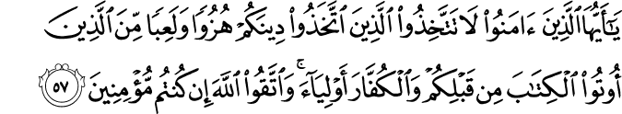
57. O ye who believe! take not for friends and protectors those who take your religion for a mockery or sport,- whether among those who received the Scripture before you, or among those who reject Faith; but fear ye Allah, if ye have faith (indeed).
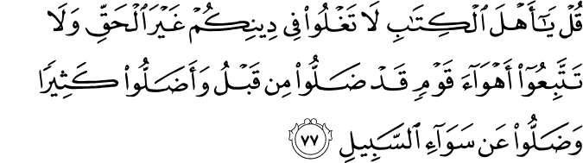
77. Say: "O people of the Book! exceed not in your religion the bounds (of what is proper), trespassing beyond the truth, nor follow the vain desires of people who went wrong in times gone by,- who misled many, and strayed (themselves) from the even way.
Surah 9 التوبۃ
12. But if they violate their oaths after their covenant, and taunt you for your Faith,- fight ye the chiefs of Unfaith: for their oaths are nothing to them: that thus they may be restrained.
Surah 26 المومن
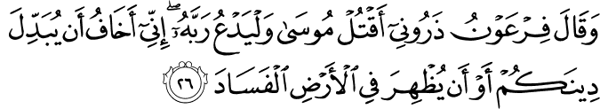
26. Said Pharaoh: "Leave me to slay Moses; and let him call on his Lord! What I fear is lest he should change your religion, or lest he should cause mischief to appear in the land!"
Surah 49 الحجرات
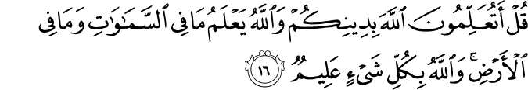
16. Say: "What! Will ye instruct Allah about your religion? But Allah knows all that is in the heavens and on earth: He has full knowledge of all things.
Surah 109 الکافرون
6. To you be your Way, and to me mine.

دینہ
البقرۃSurah 2
217. They ask thee concerning fighting in the Prohibited Month. Say: "Fighting therein is a grave (offence); but graver is it in the sight of Allah to prevent access to the path of Allah, to deny Him, to prevent access to the Sacred Mosque, and drive out its members." Tumult and oppression are worse than slaughter. Nor will they cease fighting you until they turn you back from your faith if they can. And if any of you Turn back from their faith and die in unbelief, their works will bear no fruit in this life and in the Hereafter; they will be companions of the Fire and will abide therein.
Surah 5 المائدۃ
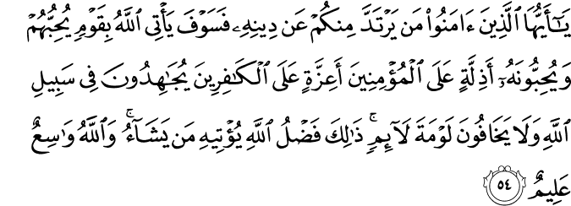
54. O ye who believe! if any from among you turn back from his Faith, soon will Allah produce a people whom He will love as they will love Him,- lowly with the believers, mighty against the rejecters, fighting in the way of Allah, and never afraid of the reproaches of such as find fault. That is the grace of Allah, which He will bestow on whom He pleaseth. And Allah encompasseth all, and He knoweth all things.
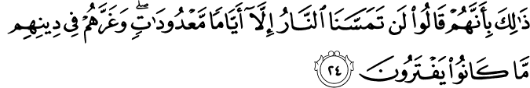
24. This because they say: "The Fire shall not touch us but for a few numbered days": For their forgeries deceive them as to their own religion.
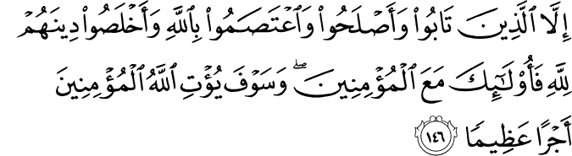
146. Except for those who repent, mend (their lives) hold fast to Allah, and purify their religion as in Allah's sight: if so they will be (numbered) with the believers. And soon will Allah grant to the believers a reward of immense value. 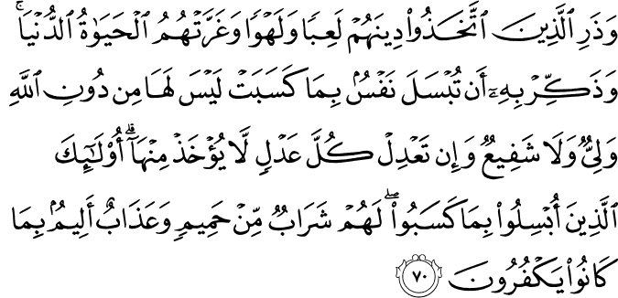
70. Leave alone those who take their religion to be mere play and amusement, and are deceived by the life of this world. But proclaim (to them) this (truth): that every soul delivers itself to ruin by its own acts: it will find for itself no protector or intercessor except Allah: if it offered every ransom, (or reparation), none will be accepted: such is (the end of) those who deliver themselves to ruin by their own acts: they will have for drink (only) boiling water, and for punishment, one most grievous: for they persisted in rejecting Allah.
127. For them will be a home of peace in the presence of their Lord: He will be their friend, because they practised (righteousness). 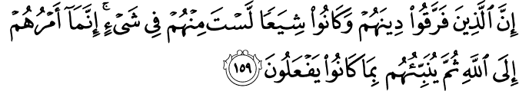
159. As for those who divide their religion and break up into sects, thou hast no part in them in the least: their affair is with Allah: He will in the end tell them the truth of all that they did. 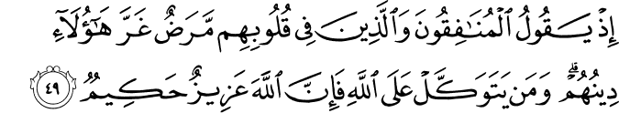
49. Lo! the hypocrites say, and those in whose hearts is a disease: "These people,- their religion has misled them." But if any trust in Allah, behold! Allah is Exalted in might, Wise.
25. On that Day Allah will pay them back (all) their just dues, and they will realise that Allah is the (very) Truth, that makes all things manifest. 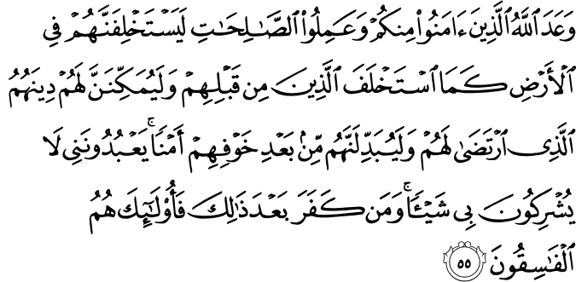
55. Allah has promised, to those among you who believe and work righteous deeds, that He will, of a surety, grant them in the land, inheritance (of power), as He granted it to those before them; that He will establish in authority their religion - the one which He has chosen for them; and that He will change (their state), after the fear in which they (lived), to one of security and peace: 'They will worship Me (alone) and not associate aught with Me. 'If any do reject Faith after this, they are rebellious and wicked. 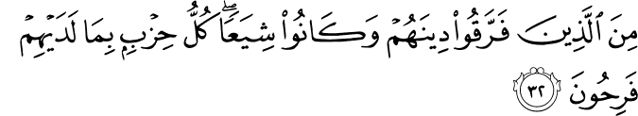
32. Those who split up their Religion, and become (mere) Sects,- each party rejoicing in that which is with itself!
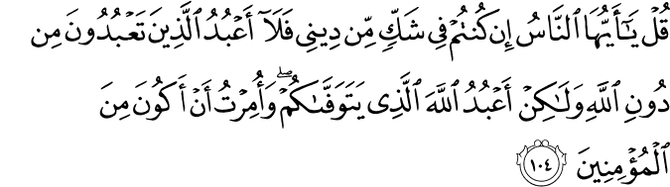
104. Say: "O ye men! If ye are in doubt as to my religion, (behold!) I worship not what ye worship, other than Allah! But I worship Allah - Who will take your souls (at death): I am commanded to be (in the ranks) of the Believers,
14. Say: "It is Allah I serve, with my sincere (and exclusive) devotion:
شریعت
Surah 45 الجاثیہ
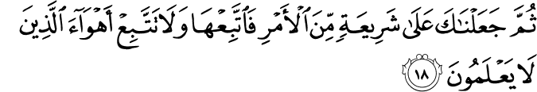
18. Then We put thee on the (right) Way of Religion: so follow thou that (Way), and follow not the desires of those who know not.

Surah 42سورة الشورى

13. The same religion has He established for you as that which He enjoined on Noah - the which We have sent by inspiration to thee - and that which We enjoined on Abraham, Moses, and Jesus: Namely, that ye should remain steadfast in religion, and make no divisions therein: to those who worship other things than Allah, hard is the (way) to which thou callest them. Allah chooses to Himself those whom He pleases, and guides to Himself those who turn (to Him).
21. What! have they partners (in godhead), who have established for them some religion without the permission of Allah? Had it not been for the Decree of Judgment, the matter would have been decided between them (at once). But verily the Wrong-doers will have a grievous Penalty.

Surah 19 سورة مريم
69. Then shall We certainly drag out from every sect all those who were worst in obstinate rebellion against (Allah) Most Gracious.

Surah 28 سورة القصص

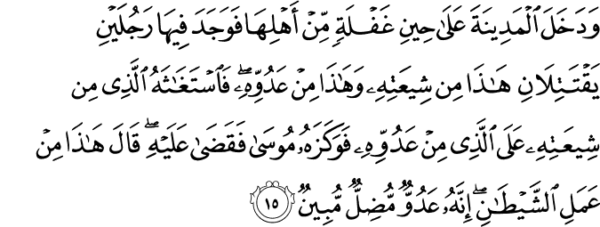

15. And he entered the city at a time when its people were not watching: and he found there two men fighting,- one of his own religion, and the other, of his foes. Now the man of his own religion appealed to him against his foe, and Moses struck him with his fist and made an end of him. He said: "This is a work of Evil (Satan): for he is an enemy that manifestly misleads!"

Surah 28 سورة الصفات

83. Verily among those who followed his Way was Abraham.

Surah 09 سورة التوبۃ

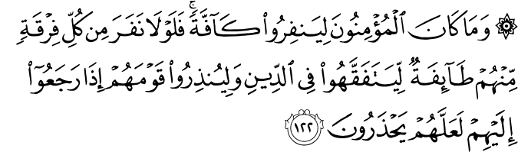
122.Nor should the Believers all go forth together: if a contingent from every expedition remained behind, they could devote themselves to studies in religion, and admonish the people when they return to them,- that thus they (may learn) to guard themselves (against evil).
الاعراب

Surah 09 سورة التوبۃ

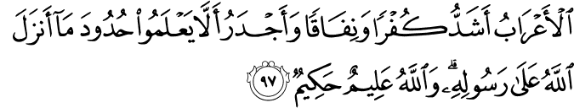
97. The Arabs of the desert are the worst in Unbelief and hypocrisy, and most fitted to be in ignorance of the command which Allah hath sent down to His Messenger: But Allah is All-knowing, All-Wise.
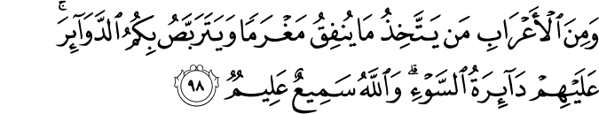

98. Some of the desert Arabs look upon their payments as a fine, and watch for disasters for you: on them be the disaster of evil: for Allah is He That heareth and knoweth (all things).
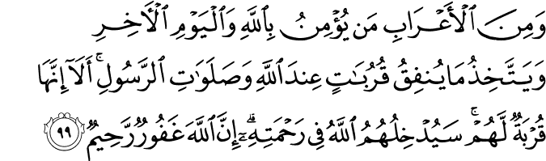

99.But some of the desert Arabs believe in Allah and the Last Day, and look on their payments as pious gifts bringing them nearer to Allah and obtaining the prayers of the Messenger. Aye, indeed they bring them nearer (to Him): soon will Allah admit them to His Mercy: for Allah is Oft-forgiving, Most Merciful.

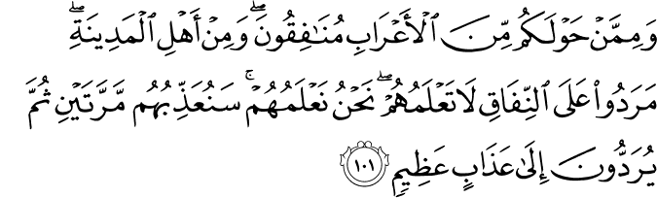
101. Certain of the desert Arabs round about you are hypocrites, as well as (desert Arabs) among the Medina folk: they are obstinate in hypocrisy: thou knowest them not: We know them: twice shall We punish them: and in addition shall they be sent to a grievous penalty.
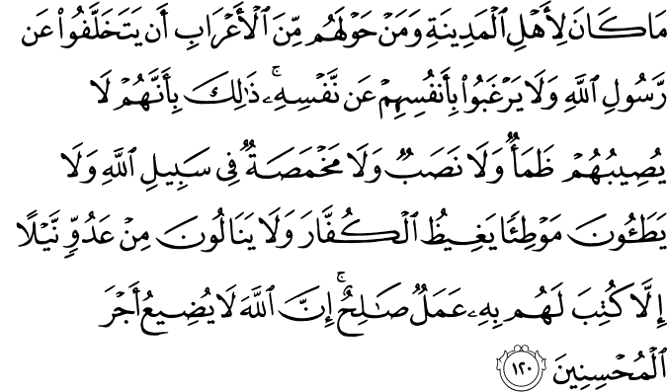

120.It was not fitting for the people of Medina and the Bedouin Arabs of the neighbourhood, to refuse to follow Allah's Messenger, nor to prefer their own lives to his: because nothing could they suffer or do, but was reckoned to their credit as a deed of righteousness,- whether they suffered thirst, or fatigue, or hunger, in the cause of Allah, or trod paths to raise the ire of the Unbelievers, or received any injury whatever from an enemy: for Allah suffereth not the reward to be lost of those who do good;-

Surah 33 الاحزاب
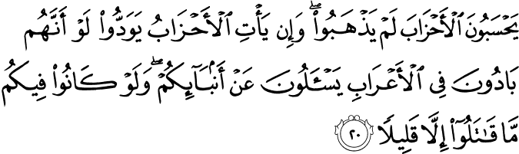
20. They think that the Confederates have not withdrawn; and if the Confederates should come (again), they would wish they were in the deserts (wandering) among the Bedouins, and seeking news about you (from a safe distance); and if they were in your midst, they would fight but little.
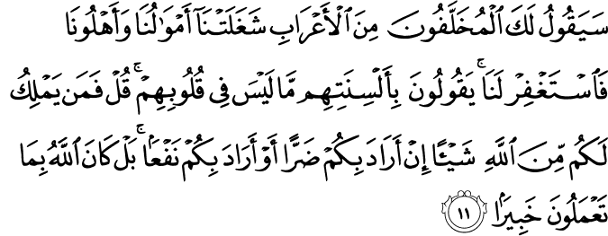
11. The desert Arabs who lagged behind will say to thee: "We were engaged in (looking after) our flocks and herds, and our families: do thou then ask forgiveness for us." They say with their tongues what is not in their hearts. Say: "Who then has any power at all (to intervene) on your behalf with Allah, if His Will is to give you some loss or to give you some profit? But Allah is well acquainted with all that ye do.
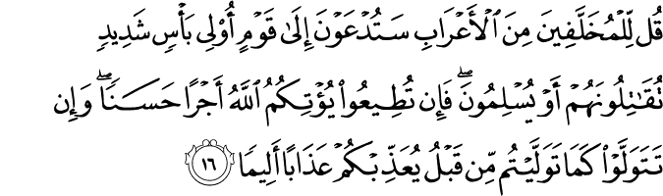
16. Say to the desert Arabs who lagged behind: "Ye shall be summoned (to fight) against a people given to vehement war: then shall ye fight, or they shall submit. Then if ye show obedience, Allah will grant you a goodly reward, but if ye turn back as ye did before, He will punish you with a grievous Penalty."
Surah 49 الحجرات
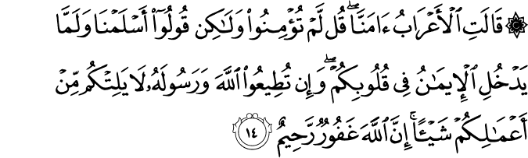
13. The desert Arabs say, "We believe." Say, "Ye have no faith; but ye (only)say, 'We have submitted our wills to Allah,' For not yet has Faith entered your hearts. But if ye obey Allah and His Messenger, He will not belittle aught of your deeds: for Allah is Oft-Forgiving, Most Merciful."

